* **[Change how Office files open by default](https://sharepoint.rackspace.com/Learning/Articles/Pages/SharePoint-2013--change-how-office-files-open-by-default.aspx)**

In SharePoint 2013, you have the ability to change how Office files open by default.  What exactly does this mean? To put it simply, you can choose to have files open in your browser or open in the client application.  
  
1. From your SharePoint site, open any document library you would like, in this example I will open my **Documents** library.

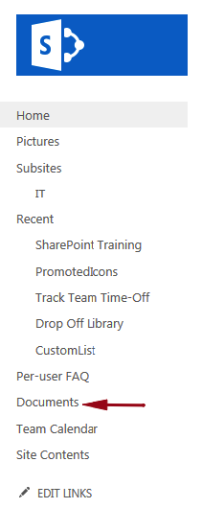

2. In the upper-left click **LIBRARY**.

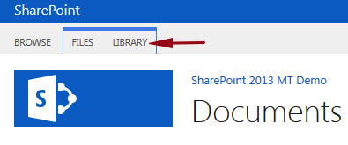

3. In the Settings section, click **Library Settings**.

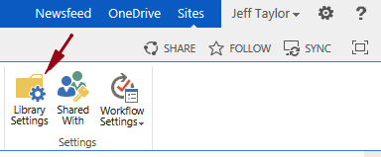

4. On the Document Settings page under general settings click **Advanced settings**.

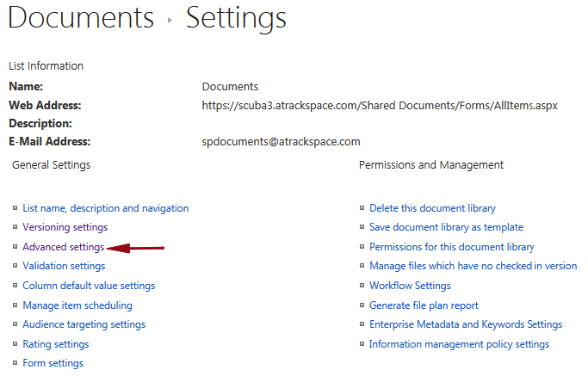

5. On the Advanced Settings page click the radio button next to **Open in the client application**.

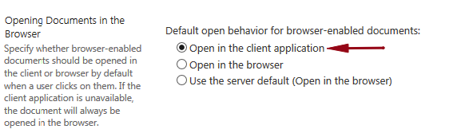

6. Scroll to the bottom and click **OK**.

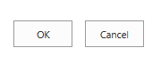

Simple as that!  Now all of your Office files will open directly in your client application instead of the browser.

​